Dear Customer,

Thank you for purchasing RK Royal Kludge **RK84** RGB Keyboard.

Please find the appropriate software version according to the **S/N code** on the back of the keyboard.

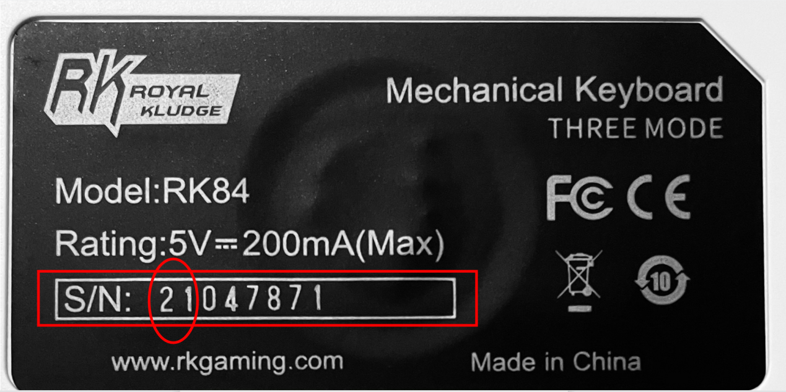

* If the S/N Code begins with the **21**, please use the File named <**Files for SN Code begins with the 21**>. When finish installation, the software logo will be as follow:

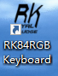

Note: This software may have some bugs and we are working on a software upgrade. The Newest software will be announced on the product details page on **Amazon** and **official website.**

* If the S/N Code begins with the **20**, please use the File named <**Files for SN Code begins with the 20**>. If you meet any issue, please use the firmware to fix it. When finish installation, the software logo will be as follow:

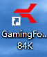

If you have any questions, please feel free to contact us via <[support@rkgaming.com](mailto:support@redragonshop.com" \t "_blank)>. Thank you.

Have a nice day!

Regards,

RK Royal Kludge